**ENGO 641 - Design and Implementation of Geospatial Information Systems**

Assignment 3 part 2

|  |  |
| --- | --- |
| **COURSE INSTRUCTOR:** | **DR. EMMANUEL STEFANAKIS** |

|  |  |
| --- | --- |
| **DATE OF SUBMISSION:** | **2023 – 10 – 31** |

|  |  |
| --- | --- |
| **NAME** | **UCID** |
| AMRESH SHARMA | 30233389 |
| ISSAC KWABENA AGYAPONG | 30222691 |
| UJJAL BANIYA | 30232571 |

***Information of Geopackage***

We utilized the CanVec feature from the Government of Canada's Geospatial Data Extraction Tool <https://maps.canada.ca/czs/index-en.html> to extract GeoPackage (.gpkg) data. The extracted data(canvec_231031_433813.gpkg) covers a geographic region of approximately 100 x 100 km, centred around Calgary. We specifically selected hydrographic and transport characteristics for extraction. The hydrographic layer is composed of the network of Canadian surface waters this includes entities such as watercourse, water linear flow, hydro obstacles (falls, rapids…), waterbody (lake, watercourse…), permanent snow and ice, water well, and spring. The transport layer is composed of, among others, the National Road Network (NRN), and the National Railway Network (NRWN) which includes entities such as Nautical Facility, Track Segment, Track Junction, Railway Station, Track Crossing, Track Marker Post, Track Structure, Rail Ferry, Road Segment, Road Ferry, Road Junction, Blocked Passage, Toll Point, Aerial Cableway, Footbridge, Trail, Navigational Aid, Marina, and Runway. The GeoPackage data contains multiple layers, but we are focusing on three key layers: road_junction_0(POINT), road_segment_1(LINESTRING), and water_body_2(POLYGON). These layers are essential for visualization and attribute analysis. The road_segment_1(LINESTRING) is particularly used in queries. For detailed geographic information, we have chosen a 1:5000 scale and utilized the NAD83 CSRS projection (EPSG:4617) for the GeoPackage settings. These settings allow us to examine the data in-depth and facilitate visualization and analysis:

Figure 1: Attributes of selected Geopackage

Figure 2: Selected Clipping Area

***Metadata of Selected Layers***

The Metadata along with visualization of layers road_junction_0(POINT), road_segment_1(LINESTRING), and water_body_2(POLYGON) is shown below:

1. ***road_junction_0(POINT):***

Figure 3: Metadata of road_junction_0

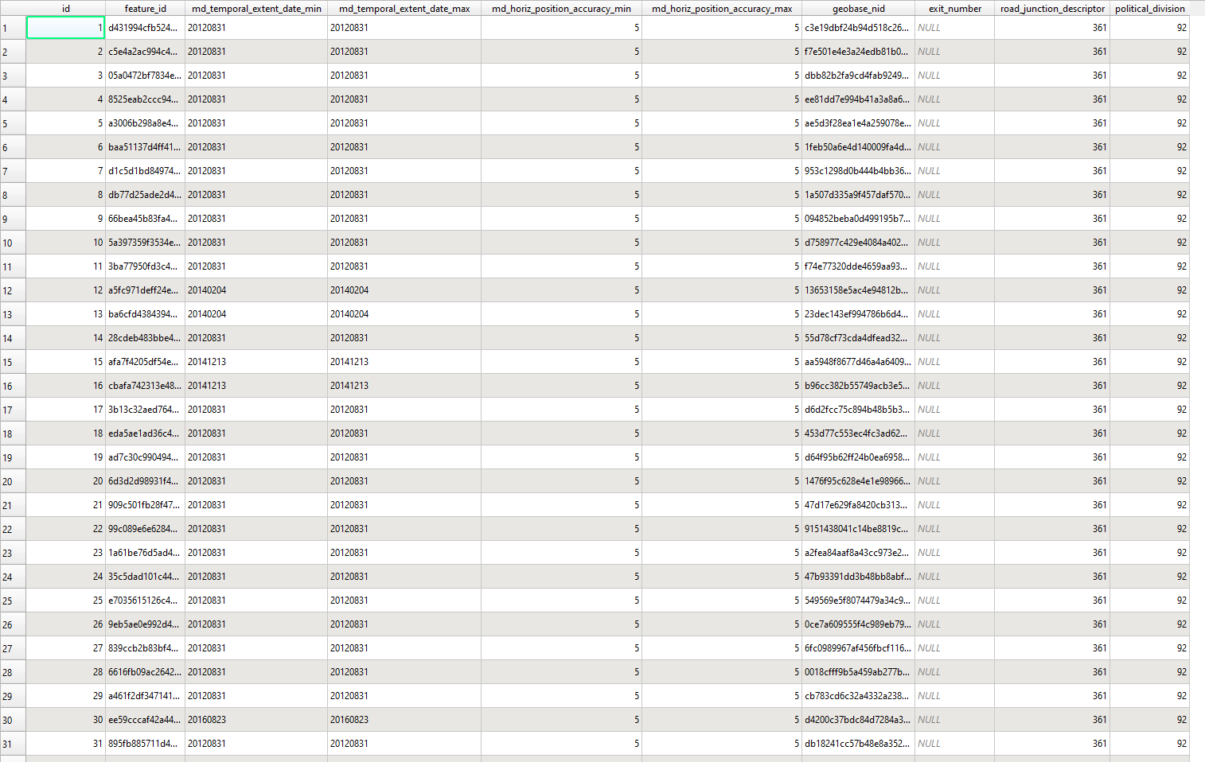

Figure 4: Attribute Table of road_junction_0

Visualization:

Figure 5: Visualization of road_junction_0

1. ***road_segment_1(POINT):***

Figure 6: Metadata of road_segment_1

Figure 7: Attribute Table of road_segment_1

Visualization:

Figure 8: Visualization of road_segment_1

1. ***water_body_2(POINT):***

Figure 9: Metadata of water_body_2

Figure 10: Attribute Table of water_body_2

Visualization:

Figure 11: Visualization of water_body_2

***Visualization of All three layers:***

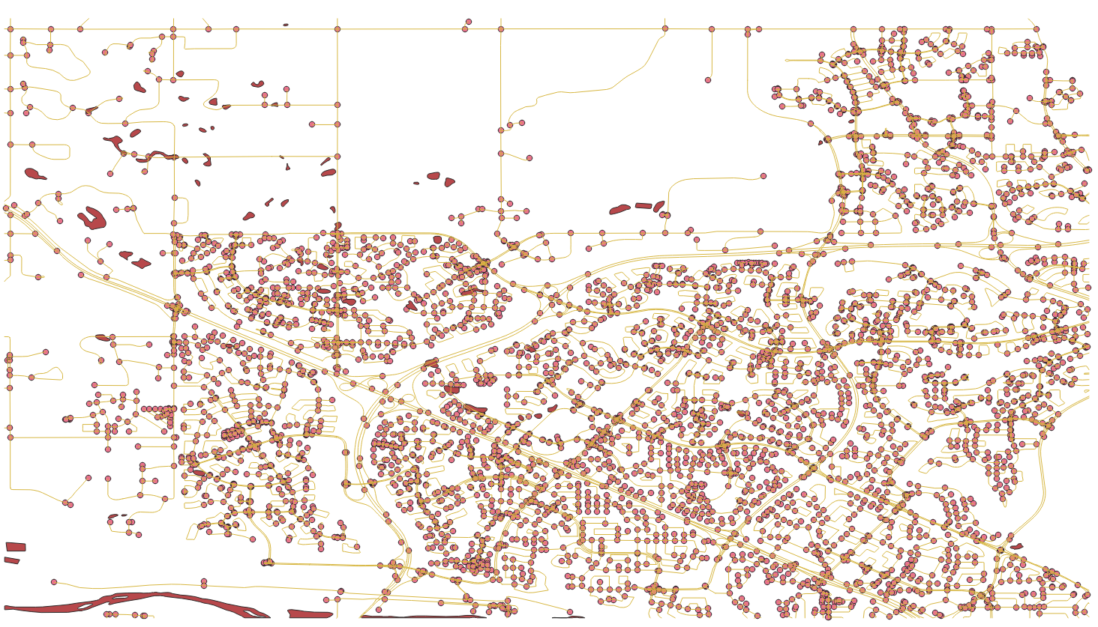

Figure 12: Visualization of All Three Layers